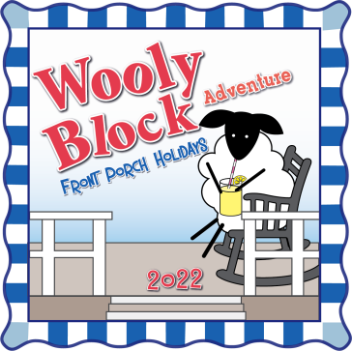
Wooly Block Adventure 2022 Participating Shops in alphabetical order

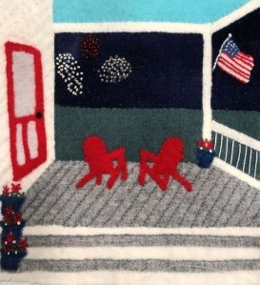
Barnegat Bay Dyeworks
barnegatbaydyeworks.com

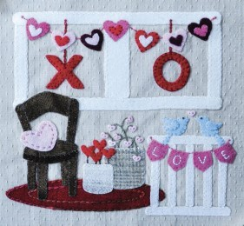
Blueberry Backroads
blueberrybackroads.com

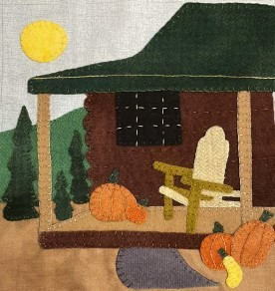
Calico Gals
calicogals.com

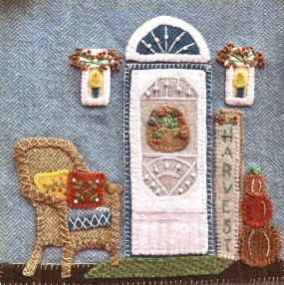
Calico Patch Designs
calicopatchdesigns.com

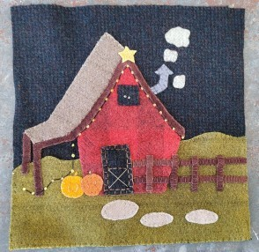
Carriage Country Quilts
carriagecountryquilts.com
Fiddlesticks
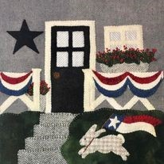
Fiddlesticksquiltshop.com

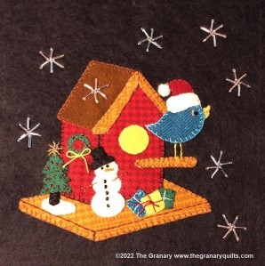
Granary Quilts
thegranaryquilts.com

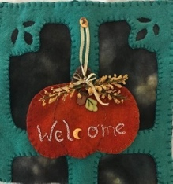
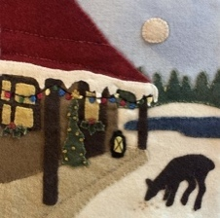
Half Moon Handwerks
Halfmoonhandwerks.com

In The Wool
Inthewool.com

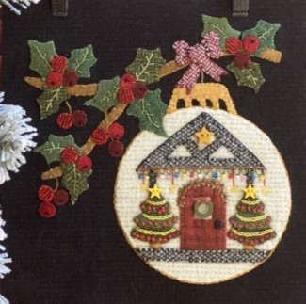
My Red Door Designs
Myreddoordesigns.com

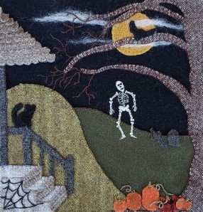
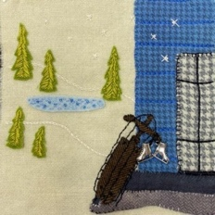
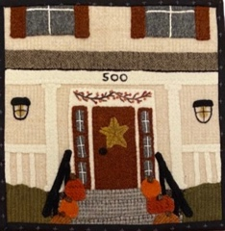
Christmas Goose Quilt Shop, The
christmasgoose.com

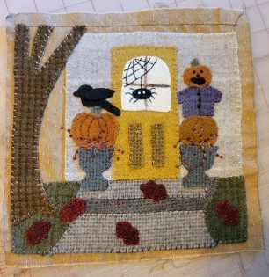
Cottage Rose, The
cottagerosequiltshop.com

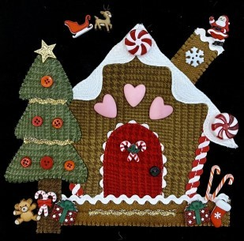
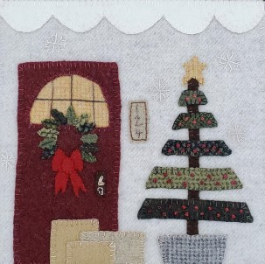
Cotton Pickins’ Quilts
cottonpickins.com
Neked Sheep Wool
Nekedsheepwool.com

Pieceful Gathering Quilt Shop
Piecefulgathering.com

Prairie Point Junction
Prairiepointjunction.com

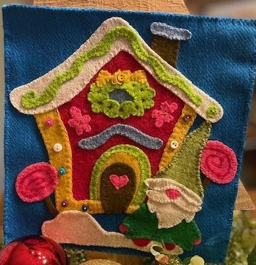
Quilt Rack & Wool Cubby
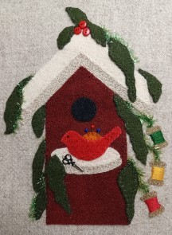
the-quilt-rack.com Quilter’s Fancy
Quiltersfancy.com

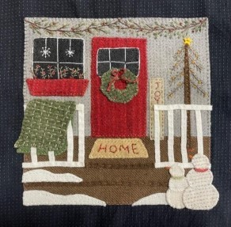
Red Button Quilt Co.
Redbuttonquiltco.com

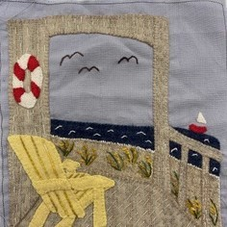
Rusty Crow Quilt Shop
Rustycrow.com

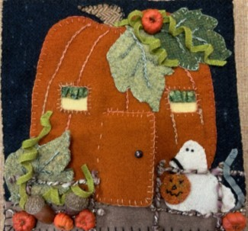
Searsport Rug Hooking
Searsportrughooking.com

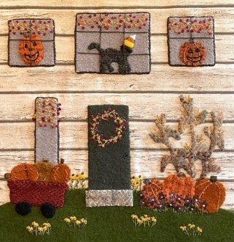
Sew Graceful Quilting
Sewgracefulquilting.com
Through the Needles Eye
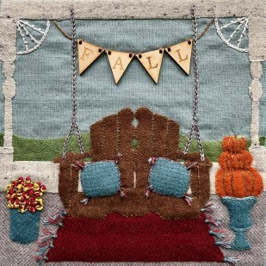
Needleseyestories.com

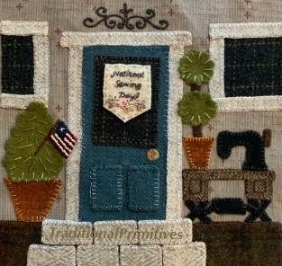
Traditional Primitives
Traditionalprimitives.com

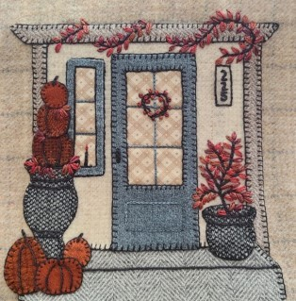
Woolen Needle, The
Thewoolenneedle.com

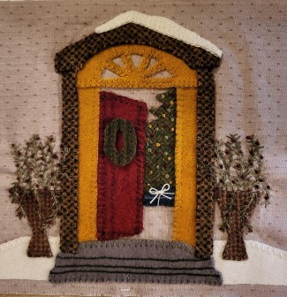
Yellow Creek Quilt Designs
yellowcreekquiltdesigns.com

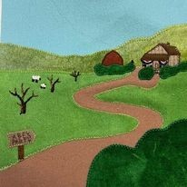
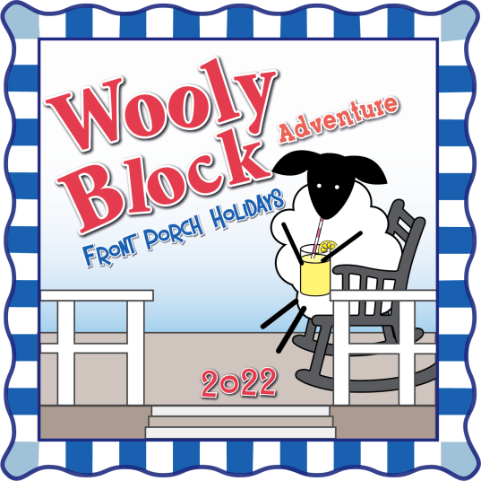
Sew Simple of Lynchburg
Amyquilts.com

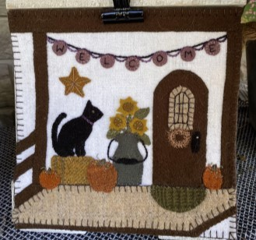
Shades of the Past Quilt Shop
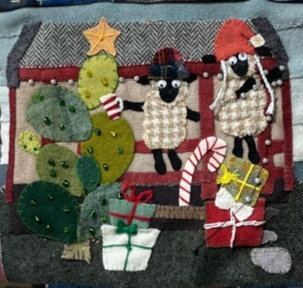
Shadesofpast.com

Sheepwalk Ranch, The
Thesheepwalkranch.com

Wooly Block Adventure 2022 starts Oct. 1 and ends Nov. 30th. Each shop will have spotlight days where their blocks will be a free download on their website! Check the Wooly Block Adventure Facebook page and the Wooly Block Neighborhood group for all the details.

